**Essentials To ICT Daytrading**

This is the hardest, because you capitilize on the daily range We want to atleast capitilize on 65-75% of the daily range

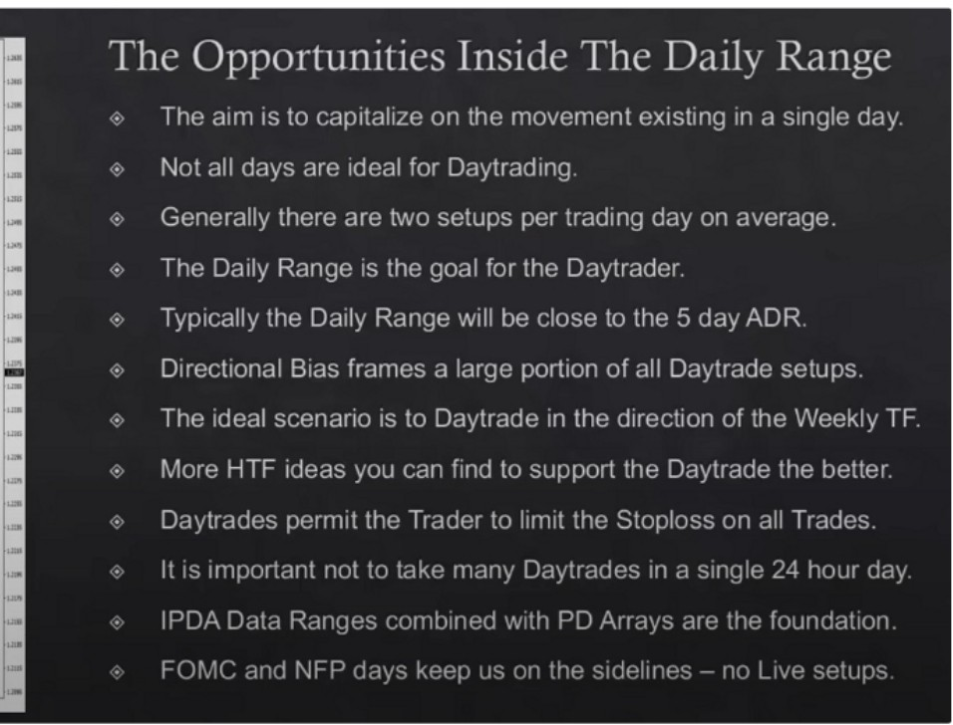

I

**j**·,

-•I

I

I,.

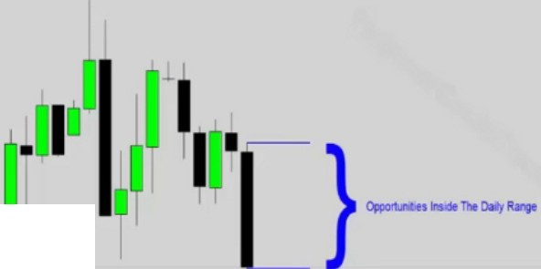

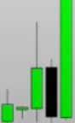

We focus primarily on the daily for daytrade PD arrays We focus on the next weekly expansion, higher or lower

Were demanding specific times to occur in a window of time, were flexibile with time, we demand preciseness from price

# What Frames The Daily Setups

0 HTF Institutional Order Flow

0 IPDA seeking new levels in Price for liquidity

0 \Vcckly Chart current candle direction

0 Day Of Weck

,;, Time Of Da\·

VoL11ilit\ L\J1,rnsio11 or "Lirgc !bi!\ R,rngcs"

Time Of Day

0 London Session Open

0 New York Session Open

0 London Close

0 New York Close

0 J\sian Session Open

•·· London Lunch

Time of day

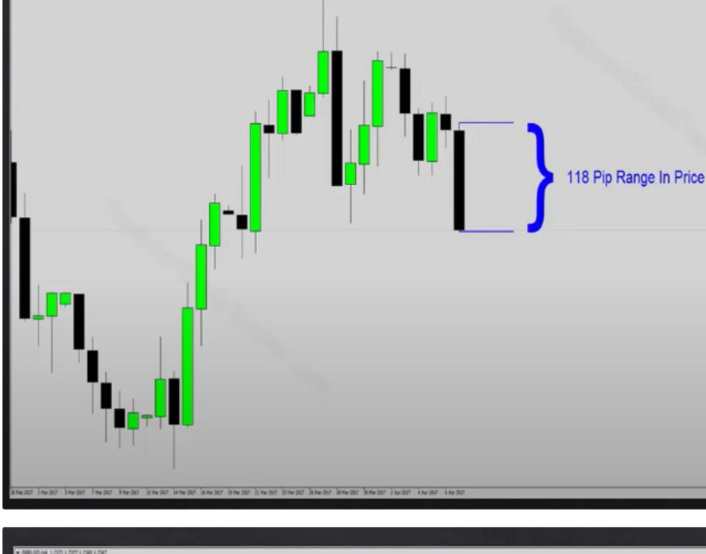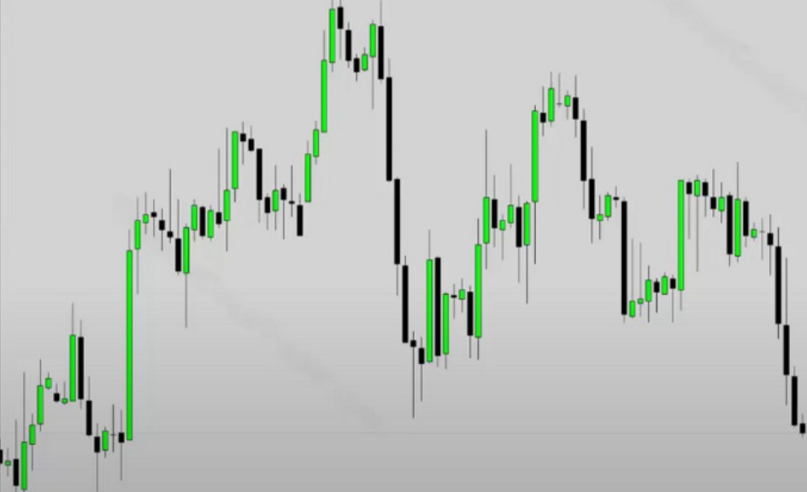

•-- ,._ • .,_ ,...,. ,._ ., .,._ ..,_,.,. ,._•,..•• ., .·,..-·..-u,

London session open: the hotspot is 2am to 4am. London can be more of a beast it requires more knowledge

To account for daylight savings and stuff, ICT uses 1am to 5am for London

New York session open, the easiest one to work with

The only time to avoid New York is when London makes 80% of the daily range, 80% of the last 5 days average range

London close,

We look to bank our positions here. There could be a reversal sometimes, and many times it provides an entry for one shot one kill, swing trades and position trades

New york close, 2pm-3pm close of the bond market

Asian session open,

Good for AUD YEN and NZD pair, many times it can create the daily low/high for those pairs

London Lunch, 5am-7am

Quiet time, it can be a consolidaiton or continuation or retracement. Its good to take profits in London before 5am because it can be a reversal or deeper retracement

Day of week

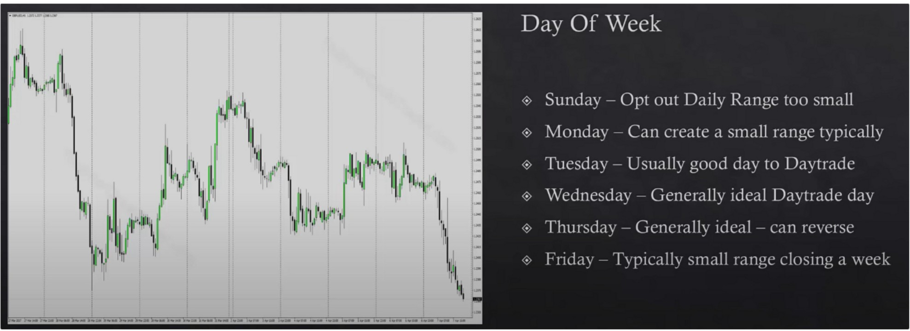

Sunday, some providers use daily candles if yours doesnt then dont worry about it and later when ICT refers to sunday candles just use monday candles

Monday,

If its a large range and you understand where youre at and trades into a premium relative to the daily that can many times be the high of the week vice versa for low of the week.

Tuesday,

70% of creating the low of the week in London

Wednesday,

You have more data from the beginning of the week

Thursday,

Usually weekly range is capped by new yorks thursday session, so be aware of that it could reverse the week

Friday,

If there are objectives that havent been met by thurday in terms of PD arrays then you could see a surprise expansion into the PD array. If thursday met the daily PD array for the weekly range then chances are friday will be a quiet day

The weekly range framework

# The Weekly Range Framework

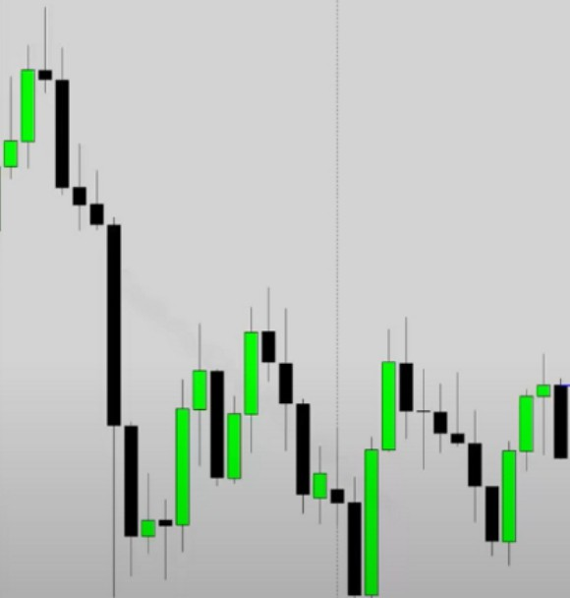

**SlmayOpelWIQPru**

. ... -- ... - .... --............ .

0

with.

Sunday - We determine the new Trading Week Opening !'rice. This will aid us intra­ week with Daytrade directional bias to work

0 Note this Sunday Open through vour 60 minute chart up to Thursdav.

If your broker doesnt use sundays data then just use the opening on monday To thursday because on thursday you could see a reversal unfold for the week

If price went above sundays opening during thursday then we probably reversed and we had a major intraweek reversal, and that many times indicates a longer term one shot one kill bullish setup next week or friday

# The Weekly Range Framework



,,..,

·1,

l1

H

iPl'j'

1-1

'I

'1/lj,l/11f'h,

11/1,

l1

1,

'1

-

,_ -

0

Sunday Opening Price Filter - We look for

!'rice to trade above this level early in the week during Bearish Weekly directional bias.

0

*J\s* long as !'rice is lower than this Sunday Opening Price each day of the week - we look to Sell Short in our Davtradcs.

Until a I ITF !'I) ;\rr,1v is tr,1dcd to.

We short every session if were below the sunday opening so we short the high in London and look for a continuation sell in New York, until we reach an opposite PD array then we can expect a reversal

Now for bullish, if we expect the daily chart to be bullish

We buy as long as were above sunday opening, so we buy the low in London and continuation buy in New York is the optimal

# The Weekly Range Framework

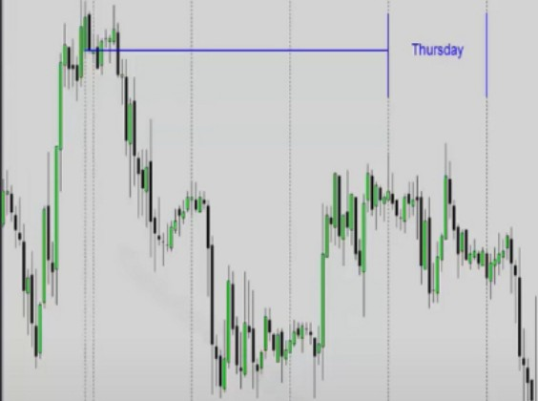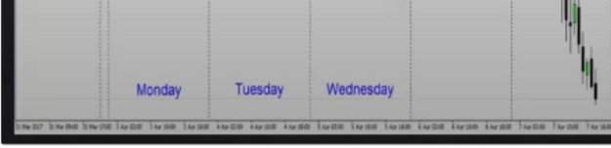

,...,

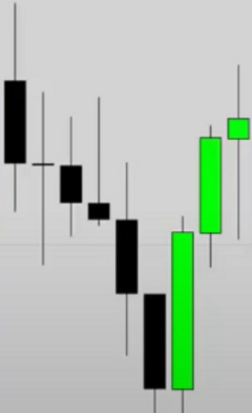

I

0

Sunday Opening Price Filter - We look for Price to trade below this level early in the week during Bullish Weekly directional bias.

0

As long as Price is higher than this Sunday Opening Price each day of the week we look to 11uv Long in our Davtradcs.

Until ,1 HTF I'D 1\rr,1v is tr,1dcd to.

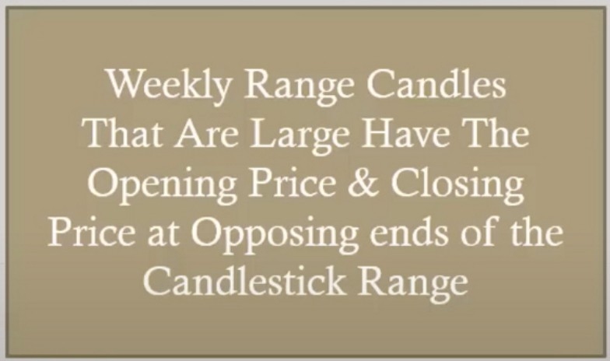When we reach the opposite HTF PD array thats when we can expect a possible reversal



**Key Point Large Range Expansion**

t

Range expansion on the weekly is a goldmine



**Close**

I

t

**Open**

I

We focus on those small wicks, in between that is our range were working with

We generally have 9 solid setups, we generally dont rush a london setup on monday but we can especially when we have a big range starting right out of the gate on sunday going into frankfurt

The sundays opening until frankfurt on monday is important, if its a big range then you focus on the high or low of the week to form on monday because its in a rush, then look at the daily and its likely aligned with a PD array

|  |  |
| --- | --- |
| **Open**  I  **Close** |  |
|  |

Its not as simple as just shorting just because we are below sundays opening on tuesday, we need to combine it with PD arrays

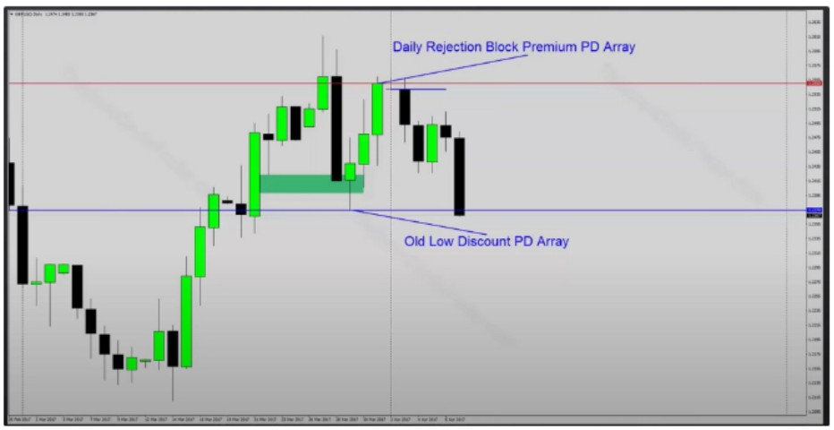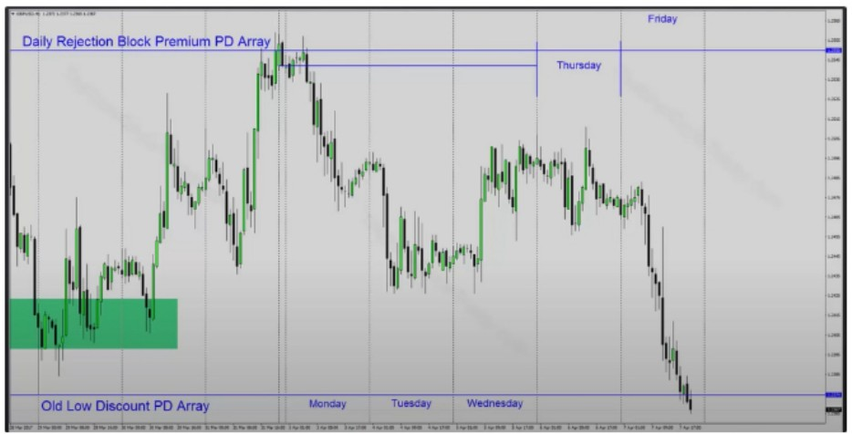

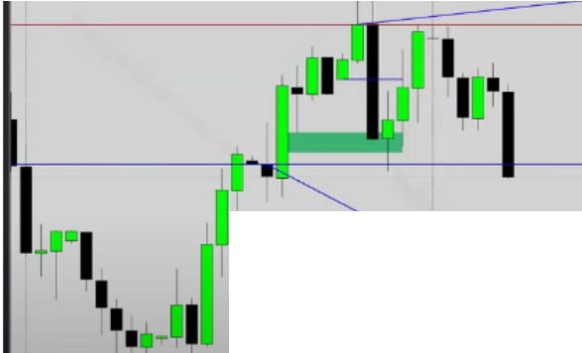

**Oa ReJeetion 81ock Prenvum PO *Array***

**Bultsh On:ietbloct low Dileount PO "'"-Y**

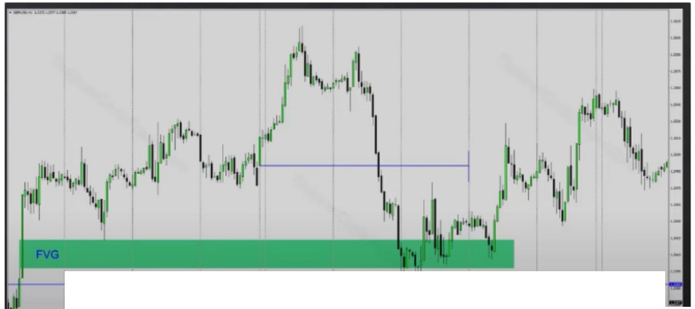

**D..iy0rscount8ul lh**



Perfect example of when not to sell below the sundays opening, we traded down into a daily FVG and a daily bullish orderblock. We

reached the opposite PD array matrix already. So we anticipate a reversal forming

Wednesday low of the week profile

You have to blend things, where are the barriers or speed bums for price. Because we understand the IPDA data range ad PD array matrix.

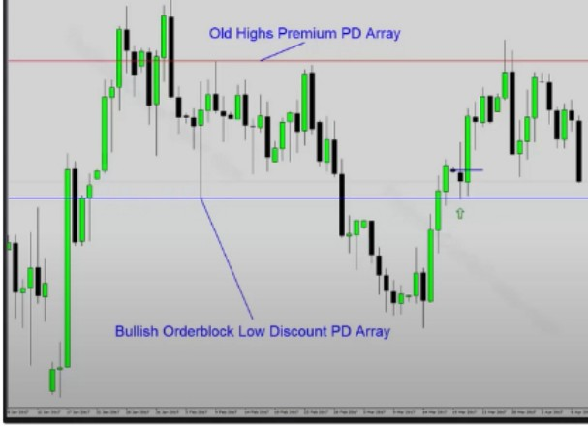

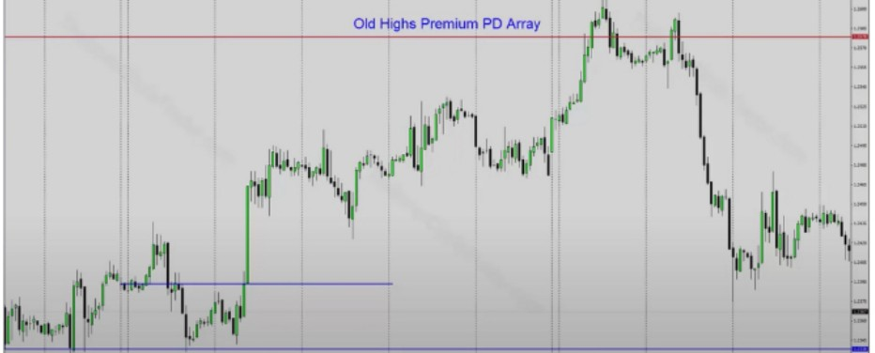

**Elulllltl Otdel't>lock Low 01tc0Unl PO Array**

Were in a discount on the daily, so we expect the weekly to close higher. So therefore we expect this everyday:

London: Open - decline, low of the day ---t buy

New york: retracement into the range that was created from london's low to the high formed prior to 8:20-8:30am in that realm, CME opening is 8:20am new york time. When that occurs generally thats going to be the setup in new york, ususally a continuation.

Notice also that we didnt reach the old highs this week, then the next week we open and immediately rally up and it makes a run for the old highs, then on tuesday we get the failure swing and we drop lower

Use sundays opening price and blend it with PD arrays on the daily chart, you can frame what the weekly range will be. Helps also with one shot one kill and It helps us knowing if we want to be a buyer or seller each day for daytrading. And if that condition is really there, if we dont get that open and decline in london that were looking for to be a buyer then we dont do anything with it. Or if we drop later in the day in new york then we can be a buyer in new york and expect the expansion to the upside

This is a strong foundation

Its important that you dont just use the sunday opening and if were below do this and above do that, no thats not how you use it. You have to blend in the PD arrays

IPDA will move from 1 PD array to the next, from a discount to a premium and from a premium to a discount. Knowing what theyre on the daily chart will help you frame the weekly range and how it will unfold.

Arjo I Twitter, lnstagram I Linktree

Linktree. Make your link do more.

I https://t.co/HhmmTN1fUI

JavaScript is not available.

"I# https://twitter.com/arjoio